Enterprise FortiGate Firewall MCP Integration Masterclass
Building an Autonomous AI Defense Shield via FortiOS REST API, LangGraph, & LangSmith

📌 Executive Overview
In this masterclass, we take our MCP knowledge to an enterprise production level by integrating an AI Agent directly with a physical or virtual FortiGate Next-Generation Firewall (NGFW) via the FortiOS REST API, orchestrated with LangGraph state machine workflows, and observed in real time with LangSmith.

🛠️ Key Project Details
Parameter | Enterprise Specification
Project Folder | d:\AI-Platform\Antigravity\Project - MCP102-FortiGate
Hardware Acceleration | MSI Raider GE68 (NVIDIA RTX 4070 GPU)
Target Firewall | FortiGate NGFW (FortiOS 7.0+ / 7.2 / 7.4)
Integration Layer | FortiOS REST API v2 (/api/v2/cmdb & /api/v2/log)
Threat Intel API | AbuseIPDB v2 REST API (https://api.abuseipdb.com/api/v2/check)
Local AI Engine | qwen2.5:latest via Ollama (RTX 4070 VRAM Accelerated)
Protocol Gateway | FastMCP Server over stdio / JSON-RPC
State Orchestration | LangGraph (StateGraph, Nodes, Edges, State Retention)
AI Observability | LangSmith Tracing & Telemetry (LANGCHAIN_TRACING_V2=true)

📐 Diagram 1: Masterclass End-to-End System Integration Architecture
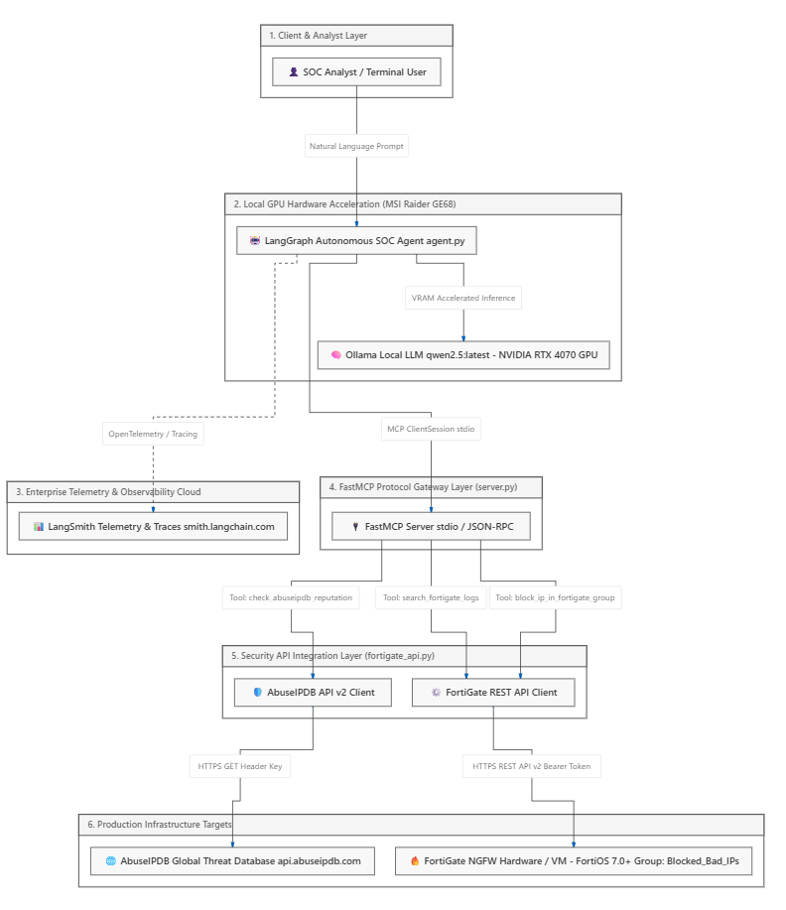

🔄 Diagram 2: LangGraph Stateful Node Execution Workflow
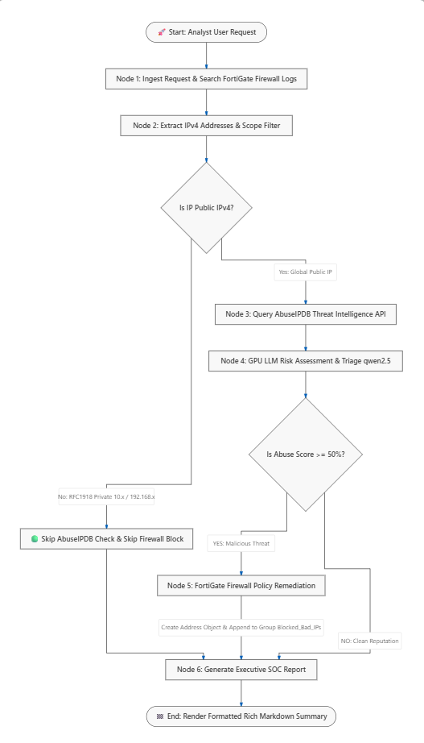

⏱️

Diagram 3: Protocol Interaction Sequence Diagram
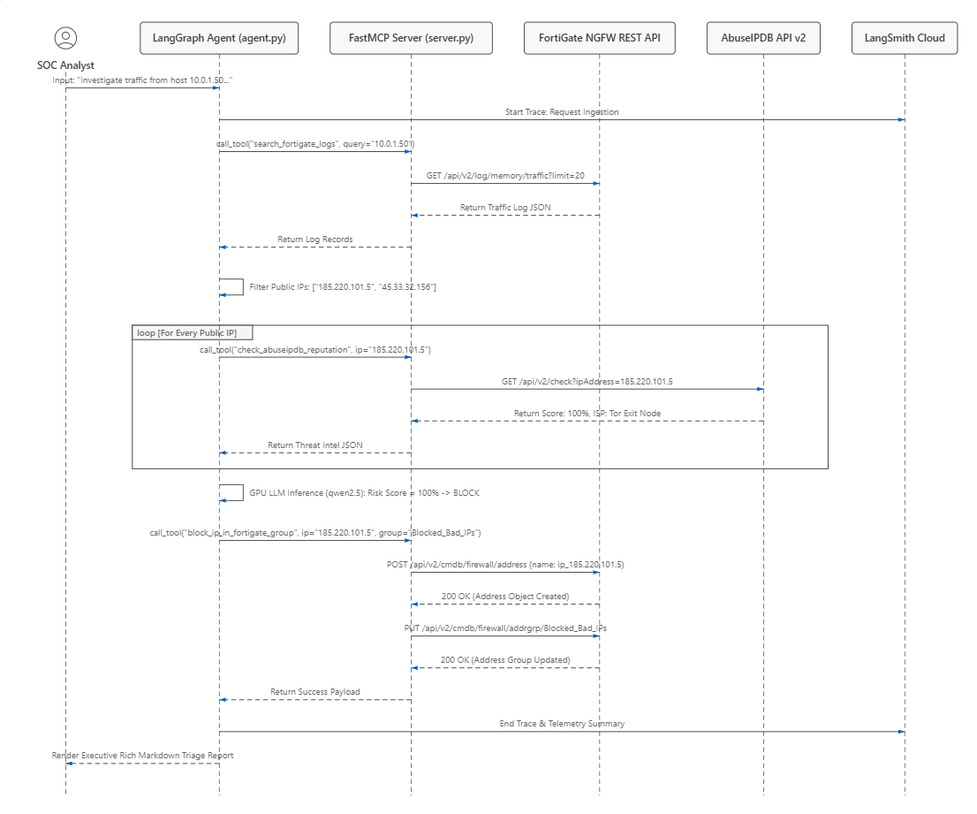

🔀 Diagram 4: Data Transformation Pipeline

📚 Step-by-Step Learning Modules (Network Expert Focus)

Module 1: Python Fundamentals & API Integration (fortigate_api.py)
- Python Code: Classes (class), Methods (def), Dictionaries (dict), Lists (list), requests.get() / requests.post(), Error handling (try/except).
- Network Application: Interfacing with AbuseIPDB v2 REST API and FortiOS CMDB REST API endpoints.
Module 2: The FastMCP Protocol Server (server.py)
- Python Code: Python Decorators (@mcp.tool(), @mcp.resource(), @mcp.prompt()), JSON serialization (json.dumps).
- Network Application: Exposing FortiGate firewall logs, status, and Blocked_Bad_IPs address group as standard MCP primitives.
Module 3: LangGraph Orchestration & LangSmith Telemetry (agent.py)
- Python Code: LangGraph StateGraph, TypedDict state classes, Node functions, Conditional Edges, LangSmith env variables.
- Network Application: Multi-node SOC triage graph: Log ingestion ➡️ Threat intel ➡️ GPU LLM Triage ➡️ FortiGate Remediation ➡️ Telemetry tracing.
Module 4: Interactive Python Console (simulation.py)
- Python Code: while True loops, sys.argv arguments, rich console formatting.
- Network Application: Running interactive SOC triage simulations.

🛠️ Verification & Validation Plan
- LangGraph State Verification: Inspecting graph transitions between log search, AbuseIPDB check, and FortiGate remediation.
- LangSmith Telemetry Trace Inspection: Verifying tool calls and LLM latency traces on smith.langchain.com.
- End-to-End FortiGate Firewall Block Verification: Verifying that malicious public IPs are added to the Blocked_Bad_IPs address group.

